***C*omputer Science and Engineering ______________________________________________________**

**GeoHealth**

**System Requirements Specification (SRS)**

**Version 1.1**

Document Number: SRS-001

Project Team Number: A26

Project Team Members: Amanda Gonzalez akg9910

Dominique Elizee dae7138

Joel Harawa jwh8918

Junwen Zhong jz4441

# **Review and Approvals**

| Team Members | Author | Date | Signature |
| --- | --- | --- | --- |
| Amanda Gonzalez | Amanda Gonzalez | 11/02/2023 | akg9910 |
| Dominique Elizee | Dominique Elizee | 11/02/2023 | dae7138 |
| Joel Harawa | Joel Harawa | 11/02/2023 | jwh8918 |
| Junwen Zhong | Junwen Zhong | 11/02/2023 | jz4441 |
|  |  |  |  |
|  |  |  |  |
|  |  |  |  |

# 

# 

# 

# 

# 

# 

# 

# **Revision Level**

| Date | Revision Level | Purpose |
| --- | --- | --- |
| 11/27/2023 | Final SRS Requirements | Completed SRS Document |
| 11/02/2023 | Analysis Specification | UML System Model, Class Diagrams, and Behavioral models |
| 10/20/2023 | Functional Requirements Specification | Descriptions of data to be entered into the system, operations performed by system, work-flows performed by the system, and system reports |
| 11/9/2023 | Final Analysis Specification | UML Class, Collaborative, Behavioral, and Sequence Diagrams to show software variable and user actions |
|  |  |  |
|  |  |  |
|  |  |  |

# 

# 

# **1.** **DOCUMENT PURPOSE**

## **1.1** **Purpose**

*This subsection describes the purpose of this document.*

*a. Delineate the purpose of this SRS*

*b. Specify the intended audience of the SRS*

1. Delineation of Purpose

The purpose of this System Requirements Specification (SRS) is to provide an outline of the functional requirements for the proposed system, GeoHealth.

1. Intended Audience

The intended audience of this SRS is the development team and the stakeholders associated with the GeoHealth project, which includes:

* Development Team: programmers and software designers, will use the SRS to guide them as they build the different functionalities of the system.
* Clients and Customers: The clients and customers will use the SRS to verify that the system matches their requirements.

# **2.** **INTRODUCTION**

*This subsection should include:*

*a. Identify the system to be produced*

*b. Refer to and state the results of the needs in the form of a brief expression of the customer’s problem(s). Explain what the system will do to meet those needs.*

*c. Describe the application of the system specified. As a part of, it should describe all relevant top-level benefits, objectives, goals as precisely as possible*

*d. Be consistent with the system proposal, if it exists*

*e. Product perspective – puts the product into perspective concerning other products if a product is truly a standalone system (explicitly stated). If it is part of a more extensive system, the interface with that system should be described.*

1. Identification of the System to be Produced

This SRS defines the requirements to be fulfilled during the development of the GeoHealth system. The system aims to provide users with information about health services nearby their location, according to their preferences and medical needs.

1. Customer’s needs and System’s solution

Customer’s of the GeoHealth product are people who have limited information about health services and what is offered in their location. Information like the type of insurance the hospital accepts, the kind of hospital and what the doctors in the hospital specialize in, and the ratings of the services will be available for the GeoHealth customers.

1. Application of System and Goals

The large-scale goal is to improve public health awareness and actions. At a smaller community level, the application should provide accessibility to local businesses, offices, and news to educate users about options they have so that they can make more informed decisions. By centralizing a map of such places, users can be as prepared as possible to tackle their health care needs. Other services such as virtual health and information can give users extra guidance about their concerns or interests.

1. Product Perspective

This product will congregate news and information. It will not provide news or recommendations from our team directly. The map will be part of a larger, already usable and accessible system, such as Google or apple maps. Other virtual options will come from participating businesses and organizations. Public news alerts will come from state or other government agencies.

## **2.1** **Scope**

*Identify functionality that is included in the system and functionality that is NOT included in the system. Must be consistent with the Context Diagram.*

The ability to provide wide scale public health information catered to users’ local area improves community health efforts and elevates business outreach.

Users will interact with their local community health resources through public health information or business profiles and directions. The system will forward those contacts to the business to help them be more seen. In turn, businesses will provide customer services through the software as needed.

The scope will not include users’ personal health information. They should not be able to input sensitive details directly to health businesses. Businesses in turn should also not be able to promote their offices or services because this can lead to influenced/biased suggestions.

## **2.2** **Identification**

*Identification of this document (name, number, revision)*

Document Name: System Requirements Specification for GeoHealth System

Document Number: SRS-001

Revision: 1.0

Date: 9/20/2023

## **2.3** **Bounds**

*System boundaries - derived from the scope statement in the System Project Management Plan*

1. Inclusions
   1. The system will provide public health information relevant to the users’ local areas.
   2. Users will be able to interact with the and access information about local health resources.
   3. System can forward user contacts to health businesses.
   4. Health businesses can provide customer services through the software as needed.
2. Exclusions
3. The system won’t allow users to input sensitive personal health information.
4. Health businesses will not have the ability to promote offices and services to avoid biased suggestions.

## **2.4** **Objectives**

*Including project priority, type of delivery: Life cycle (single deliverable, incremental, or evolutionary) and initial deliverable (milestone) dates.*

We are going to use an incremental, agile-type approach for our project. This means that we will have short periods of development before releases that will allow us to implement changes as we move forward in the process.

Our first milestone will be brainstorming, followed by planning (which will lead us to the final SRS due on 11/21), then modeling (for the project management plan 11/30)before we dive into software development. When we start development we may just do a template or UI before adding integral structures.

Milestone dates:

System Requirements Specification – Final (SRS - Analysis) 11/21/23

Software Project Management Plan (SPMP) 11/30/23

Project Presentation 12/7/23

## **2.5** **Context Diagram**

*Appropriate diagrams and narratives to provide an overview of the context of the system defining all significant interfaces crossing the system boundaries.*

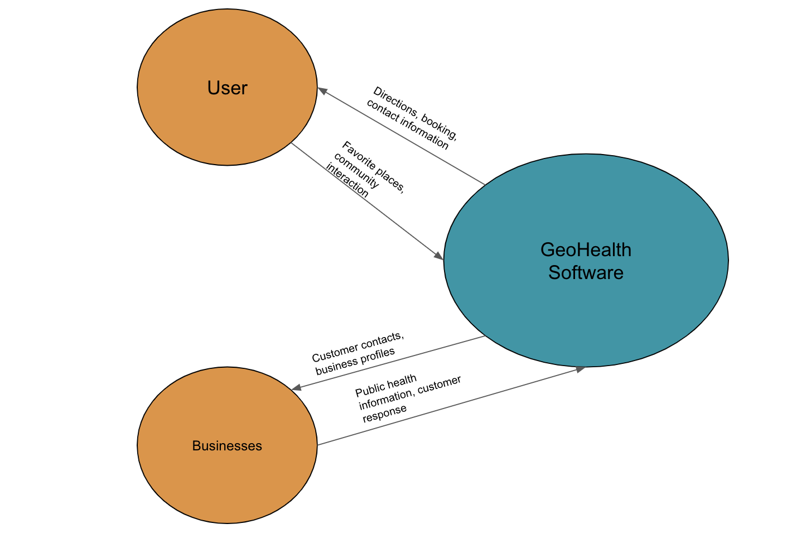

## **2.6** **Additional Descriptive Items**

*a. Product functions – provide a summary or list of the major functions that will perform (for example, an accounting system performing accounts receivable and general ledger functionality)*

*b. User characteristics – describe those general characteristics of the intended users of the product, including experience, knowledge, technical expertise. It should not state-specific requirements but rather provide the rationale why specific requirements are later specified*

*c. Constraints – provide a general description of any items that will limit the developer’s options. These* ***could*** *be based on policies and procedures and include:*

*1. Regulatory*

*2. Hardware limitations*

*3. Interface to other applications*

*4. Operations*

*5. Audit functions*

*6. Control functions*

*7. Development language*

*8. Communication protocols*

*9. Priority*

*10. Safety and security*

*d. Assumptions and dependencies – list each of the factors that affect the requirements. These factors are not designed constraints; rather, any changes to them that can affect the requirements. (For example, the specification of a specific operating system on a particular hardware platform. If the OS or hardware were not available, the requirements would have to be modified)*

*e. Requirements subsets – For iterative development, identify requirements subsets and those requirements subsets that could be delayed until future releases.*

1. Product Functions

Function 1: User Authentication and Authorization

Description: The system shall provide users with a user authentication mechanism, that allows users to securely login in and access their information.

Inputs: User credentials (username, password)

Outputs: User authentication status

Functional Requirements:

* The system shall verify credentials.
* The system shall grant access based validity of the user’s credentials.

Function 2: Health Service search

Description: The system shall have a feature that allows the users to input information about their medical needs and get options based on their search filters.

1. User characteristics

Users should be people of all backgrounds and ages. Most likely ages will be young adults to older aged adults (about 16 to 60). This is because many younger adolescents seek health care from adults, this does not exclude them from seeking out additional resources, whether that be for virtual mental health or just questions they may have. Further, older adults past 60 may not be looking for technological tools for finding services, they may just ask other people they know for recommendations or they may not be as technologically savvy (although we will attempt to make our maps and features as simple as possible to decrease any potential barriers). From these demographics, we can make sure that items are marked clearly and pages are easy to follow, but at the same time the content should be appealing and moderately modern.

2. There may be restrictions on certain medical recommendations (such as reproductive choices, or legalized substances, etc.) that need to be reviewed per state/ local area
3. No hardware limitations are seen (should be both web and phone app based)
4. There will have to be two interfaces if product in web based as well as mobile application based
5. Will vary based on if we want to do both web and app or only either. If doing app we may have to learn another programming language
6. Possible communication with businesses, but this will be through the map provider or business provider, not through our software services
7. Accessibility to all individuals and accuracy of information
8. We want to make sure that recommended businesses or places are reputable and real. Sometimes map applications allow anyone to create business, in this case, we will have some tool to either directly report to the map application for fixing or through our app to get rid of anything that may be harmful to a user. User profiles will have to be secure because we do not want their favorite or last visited searches to be able to be seen by everyone.
9. If we choose to make this an application for specific app stores, i.e. apple, android, google, we may be restricted to the type of map feature that we have. For example, if we wanted to include apple map features, this may not be transferable to android systems, therefore, a goal of our planning should be to identify the best source information that is universal.
10. Specific app store iterations could be a potential route for us to take. This could specialize experiences for different OS users. Those with apple products could support apple map features that could make their experience more seamless and the same idea goes for other OSes, but currently, the primary idea is to have a universal app.

# **3.** **GLOSSARY**

*This section should describe:*

*Define technical terms used in the document. You should not make assumptions about the experience or expertise of the reader.*

* API (application programming interface): from IBM, “is a set of defined rules that enable different applications to communicate with each other”
* OS (operating system): a program that manages the computer's software applications in relation to hardware components (ex. Windows, Mac, Linux)
* LOC (lines of code)
* UML (unified modeling language): diagram for software systems
* Interface: a point where two systems, subjects, organizations, etc. meet and interact (Oxford dictionary)
* UI (user interface): a device or program enabling a user to communicate with a computer (from Oxford dictionary)

# 4. **REFERENCE DOCUMENTS**

*Include a reference to your Project Proposal*

*Team Number, Document Name, Document Number, Version, Date*

A26, Project Proposal, PP-001, Version 1.0, September 19, 2023

# 5. **BUSINESS REQUIREMENTS**

## **5.1** **Technology**

*Business technology drivers for this system, if any*

Advancement of gps and mapping applications and systems. Utilize modern development frameworks and languages to make a user friendly system.

## **5.2** **Economics**

*Business economic drivers for this system, if any*

The saturation of health care offerings…places that don't cater towards servicing may not have many individuals looking for care (small towns) versus big cities with variable options.

## **5.3** **Regulatory and Legal**

*It May not be relevant to your project*

Based on local jurisdictions, service may or may not be available (such as reproductive care or certain substances or recommendations).

## **5.4** **Market Considerations**

*Business market drivers for this system, if any*

Some business market drivers include the following, healthcare industry trends and user needs and preferences.

## **5.5** **Risks and Alternatives**

*Identify system risks and alternative solutions to mitigate each risk*

*(see the table provided in class)*

**Business Risk:** One business risk is building a product that no one really wants.

**Description:** Having users adopt and engage with the GeoHealth system may be difficult especially if they are not willing to switch from their preferred method of searching for healthcare services.

**Probability:** Moderate

**How discovered:** Through market research.

**Responsible Party**

**Status: N/A**

**Mitigation Plan:** Design a user friendly interface to facilitate easy navigation of the GeoHealth system, continue to conduct thorough market research, and

**Operational Risk:** One operational risk is the staff size and experience.

**Description:** We may not have the experience necessary to complete this project in a timely manner.

**Probability:** High

**How discovered:** Through market research.

**Responsible Party**

**Status: N/A**

**Mitigation Plan:** The solution will be that prior to the start of the construction phase of the project our team will undergo training for creating applications, ensuring that the team's skill set will be adequate to progress with this project.

**Technology Risk:** One technology risk that has been identified is the project size.

**Description:** We are a small team so the LOC (lines of code) need to create the required functionalities may present a risk.

**Probability:** High

**How discovered: N/A**

**Responsible Party**

**Status: N/A**

**Mitigation Plan:** To combat this we plan to code together easing the stress of the programming while also being more collaborative. All together allowing an easier process.

**Economic Risk:** Revenue generation uncertainty.

**Description:** If the system fails to attract a substantial user base, it may struggle to secure advertising or partnership deals.

**Probability:** Moderate

**How discovered: N/A**

**Responsible Party**

**Status: N/A**

**Mitigation Plan:** Partnerships with healthcare providers or other stakeholders could be explored to enhance the system’s reach and financial gain.

## **5.6** **Human Resources and Training**

*Business (project) resources and training required*

Potential training for creating applications (such as swift or other development tools)

# **6.** **USER REQUIREMENTS (DESCRIPTIVE FUNCTIONAL AND NON-FUNCTIONAL REQUIREMENTS)**

Functional Definitions:

* Secure Log-In
  1. The system must recommend strong passwords when the user is setting a password.
  2. The system must be able to verify credentials.
  3. The system must grant access based validity of the user’s credentials.
* Search Functionality
  1. The system must take input from the user about what kind of healthcare service they need
  2. The system must collect data about healthcare services in the area
  3. The system must check input given by the user against the data collected and provide a top choice based on the input
* GPS and mapping applications
  1. The system must use the location of the user in order to create a map
  2. The system must display the available healthcare services on a map
  3. The system must take input about what kind of travel the user prefers
  4. The system must deduce the best route from users’ location to chosen healthcare service also based on input

Non-Functional Definitions:

* Availability of this platform
  1. Ability of a user to use this platform in the United States
  2. The system's must be able to support 5% of our target demographic at one time
  3. The system’s must be able to use different languages to display different languages

# **7.** **SYSTEM ARCHITECTURE**

The system architecture for product must is made up of the following key components working together to achieve the desired functionality. (access, data, ui, business)

User interface

* User Interface
  + This is responsible for presenting a user-friendly interface to the systems users. It should allow users to input their location and preferences to be able to retrieve information about nearby health services.
* Location Services
  + This component is needed to obtaining the user’s current location, accurately and reliably for the product to be effective.
* Information Retrieval
  + This component is required to gather information about the nearby health services. The data also needs to be sorted into certain criteria such as the type of health services that the are looking for, operational hours, insurance accepted.
* Display
  + This is needed to return the information from the user’s search for health services in an organized way. The organization should be based on the user’s search filters in a simple visual representation that the user can easily understand.
* Connectivity and Integration
  + This component is responsible for the apps communication with external services that provide necessary data for the system. This ensures that the system can work seamlessly with other existing technologies.
* Security and Privacy
  + This is used to ensure that the user’s data is kept private and secure when its being exchanged and stored. It wiil require authentication and authorization features to protect sensitive user information.

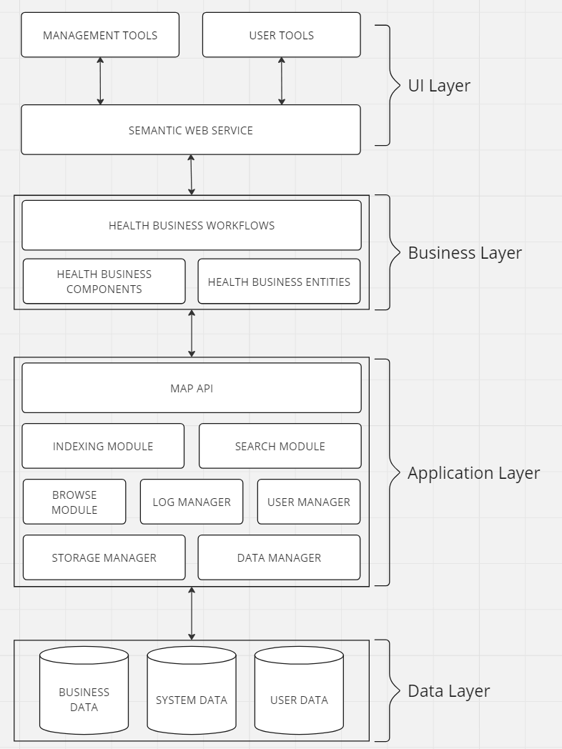

# **8.** **DETAILED SYSTEM REQUIREMENTS – USE CASES**

## **8.1** **Requirement Use Cases**

### **8.1.1** **Use Case Diagrams**

*Below is a sample use Case diagram - in your diagrams, include the boundary rectangles*

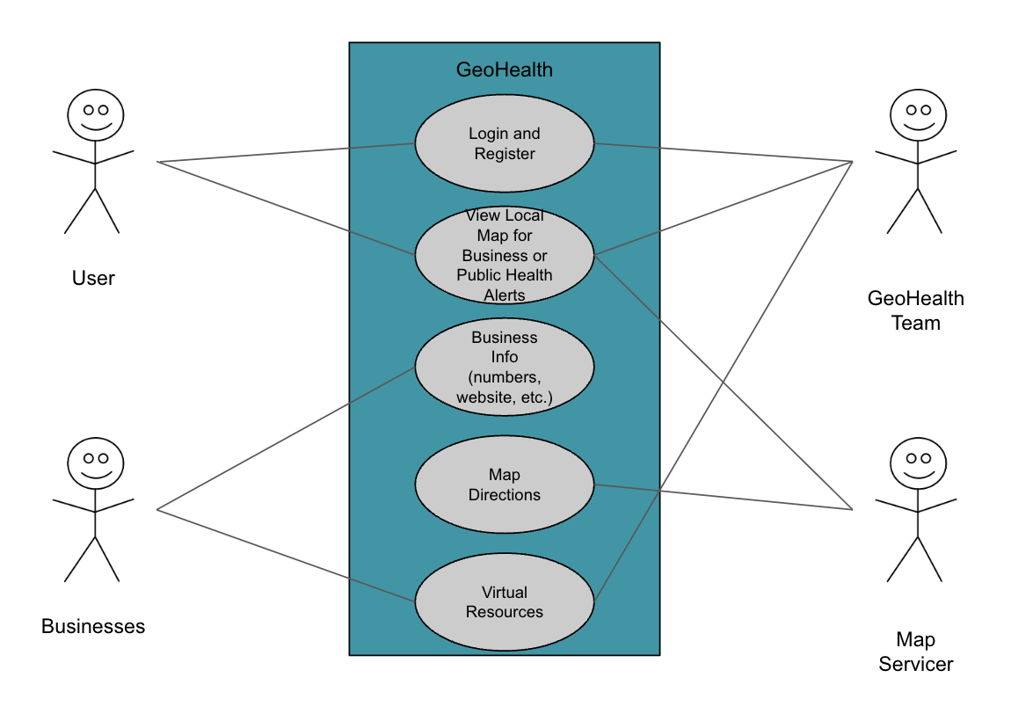

### **8.1.2** **Use Case Descriptions**

| ***Use Case Name*** | | |
| --- | --- | --- |
| **Description** | 1. Creating an account to save information and use service 2. Viewing map for business or public health alerts 3. Accessing business information 4. Receiving directions to a physical location 5. Accessing resources virtually | |
| **Pre- Conditions** | Businesses and organizations already uploaded and verified by the map servicer will be integrated into the software | |
| **Flows** | **Basic or Normal Flows** | *1.* Login or Register upon entering the app   * Stats when user opens app for first time or on start up * App prompts user to create an account if they are new, login if they are returning * Having an account allows favorites and identifiers to be stored   2. Enter location manually or through device location services   * Starts when user opens the app to search * The app prompts user for location or uses location provided from last use * Map is updated by map servicer on their schedule   *2.* Search or filter for services by insurance, type, or cost   * User can enter phrases or keywords into search bar or select from filter options * Filter options provided by GeoHealth team based on what searches are most prevalent and what services we provide * Filters will correspond with information already available on map services   *3.* View service information (ratings, number, address)   * Business provided updated information to GeoHealth to be redirected to map servicer or directly to map servicer * Business information is visible to users * Map directions from current location to business is available via the map servicer but through the app   *4.* Read about news or articles of interest   * Articles sourced from local health officials and reputable online news * Users can click on whatever articles they find most useful   *5.* Add services to favorites   * GeoHealth provides favoriting for users with an account to track and manage their favorite services * Users favorite service from map |
|  | **Alternative Flows** | *1.* Location is in a city with less resources   * Geohealth will still provide all available options for services, asking for a larger location range if needed (this will help use case continue onto #2)   *2.* Local laws do not allow for specific services or information   * The map servicer will be responsible for these regulations varied by area   *3.* Insurance type is not recognized   * Users will still be able to view other services and their costs for no insurance (this will continue the use case) |
| **Post Conditions** | User can save services even if they do not take their current insurance etc.  Local health resources or articles are updated regularly depending on government sources and outsourced networking | |
| **Special Requirements** | User information must be checked to prevent harmful usernames or unsafe passwords. | |
| **Extension Points** | * Device location services can connect directly through browser settings or device settings depending on how the software is implemented * Viewing services can be extended through being able to report services for inaccurate information, these requests will go back to the map servicer for their review * Reading articles could be extended by a browser extension such as google to use their algorithm for recommendation so no bias from GeoHealth is implemented in the results | |

# **9.** **SYSTEM MODEL (UML)**

*Graphical system model*

## **9.1** **Static - Class Diagrams**

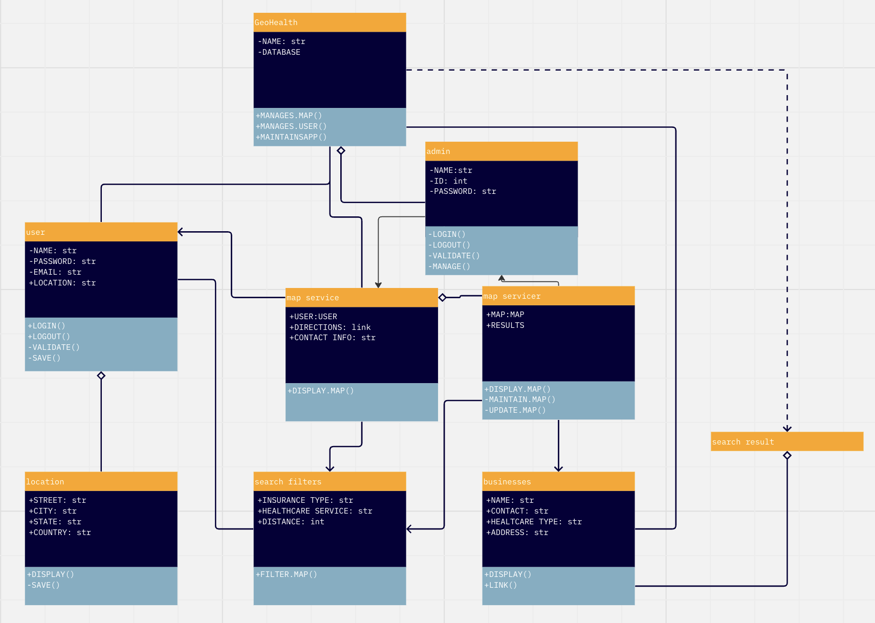

## 

## **9.2** **Dynamic - Behavioral Models**

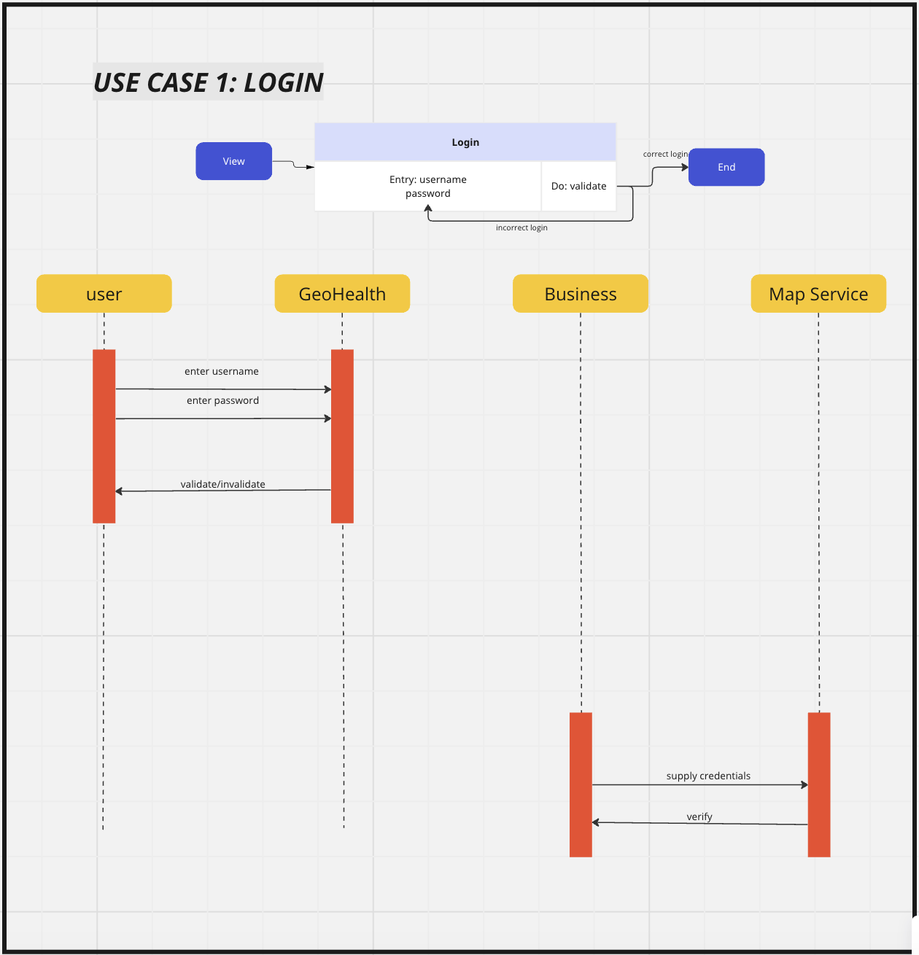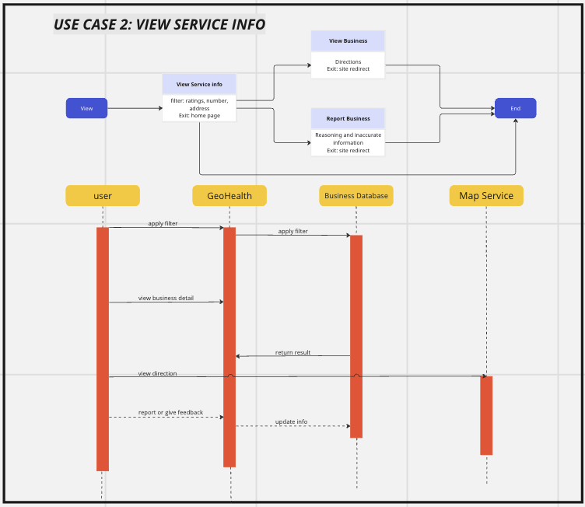

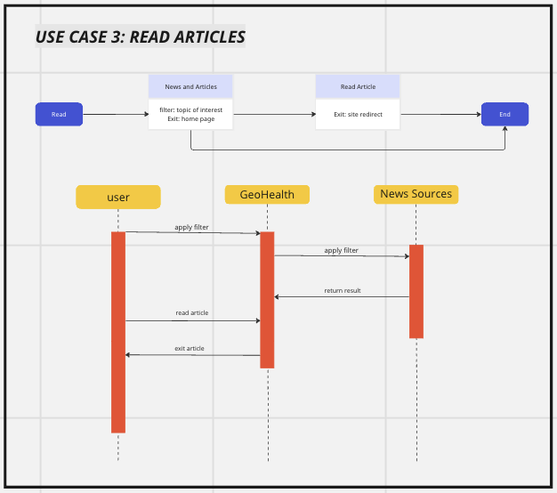

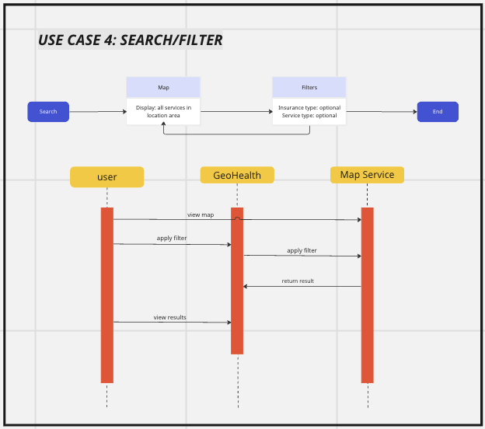

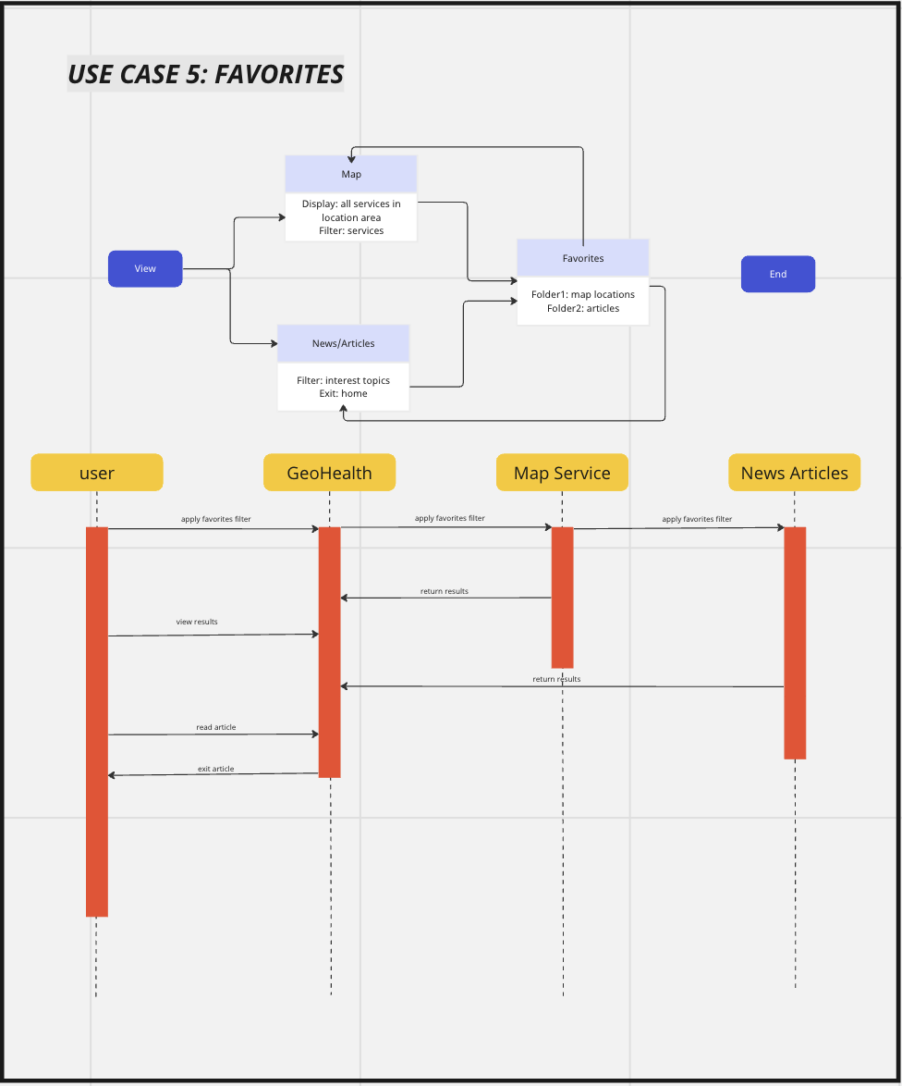

# **10.** **EVOLUTION OF THE SRS**

*This section describes how this document will evolve as the system development process progresses. It may be impossible to specify some details at the time the project is initiated because we do not have all the knowledge that is required for understanding. Additional changes may result from deficiencies, shortcomings, inaccuracies, or changes in the system environment.*

*A formal change process should be initiated to identify, control, track, and report projected changes. Approved changes should be incorporated in this document to ensure:*

*a.* *An accurate and complete trail of changes*

*b.* *Permit the review of current and superseded portions of the document*

At the start of each software development phase we will revisit this document to update how our plan and product ideas will evolve. After each phase we will do the same to cement ideas and processes that we built upon and those that were not very impactful. These discussions will help guide us through the next iterations of our product.

The schedule is something that may have to change on a micro level, meaning that exact timing of meetings weeks out is not very possible, however, deadlines are major events that will not/ can not be changed. We will also need to update sections on architecture and product details because we do not yet have a plan or model for the product that gives us a whole view of every feature we want to include.

Diagrams outlining the functionality of the product will change as we require more in depth planning of the product. They will also change when the specific functions of the product are revised or taken out.

Sections that will not need much changing include those of our goals and problems being solved. The product is based around this central mission and that is to increase public health access.

After development starts, the document will not be changed so much as referred to. Use cases may differ or increase depending on new user scenarios we may encounter or challenges with software interfaces.

# **11.** **RATIONALE**

None at this time

Short paragraph about problem (need to do project), solution provided

The search for healthcare services can be overwhelming because of the different factors such as what insurance is accepted, the cost of the healthcare, and the proximity of the healthcare. Methods to search for these can be time consuming, when having to individually search and compare to other health care services. The amount of time wasted can make a big difference in certain situations. There is a need for a solution that gives users a way to make informed decisions about their healthcare, by simplifying the data and putting it all in one place for the user. Putting it all in one place that is easily accessible and can be easily understood can save so much time and help users in a major way. This solution seeks to streamline the healthcare-seek process and ultimately contribute to improved user outcomes.

# **12.** **NOTES**

None at this time

# **13.** **APPENDICES**

## **13.1** **System Test Plan Requirements**

*In this section describe the SQA testing process, product test and acceptance testing*

SQA Management Plan:

* Set up periodic quality checkpoints to ensure that the product development is on track.
* We have established system requirements.
* Code walkthroughs act as a peer review
* Test According to the pre-established test cases and scenarios.
* Record defects and analyze the problems uncovered to provide solutions.

Test Cases and Scenarios:

* Stress testing the system to ensure its functionality under heavy loads.
* Simulate each use case to examine the behavior of the system.
* User acceptance testing to measure software quality and design features.

## **13.2** **Qualification Provisions**

*This section explains how this document will be reviewed for quality. Describes the verification and validation process that will be employed to verify the quality of the document. Include the* **four review types***. The documents should be:*

This document will be reviewed incrementally as we work through each phase of our software, if questions arise, or as we look at our use cases. The following review types will be implemented:

Desk test: these reviews have already occurred within our team when members spot errors or areas of improvement in this document. In our software development, similar reviews with our peers will occur when anything needs to be retested or redesigned. These reviews are more informal, so they can be more question based to help our peers analyze things they might have missed.

Peer reviews: These reviews will occur within all iterations of the project so that each team member is up to speed on what different sectors of the software look like and how they are lining up to our projected plan. Peer reviews are technical, so they will focus on the quality of our work and how it is holding up to stakeholder expectations.

Walkthrough: This review will be conducted as a formal meeting. Team members will prepare a report on how their work has been going and the other members will review this section of work for errors in real time.

Inspection: This review involves setting priorities for the current product and future releases and review. The inspection will work concurrently with the walkthrough phase, but provide more analysis on product timeframe and quality. At the end, the product will be accepted, rejected, or accepted with provisions.

## **13.3** **Requirements Traceability**

Domain specification: sections 1 through 4

Descriptions of data to be entered into the system, operations performed by system, work-flows performed by the system, and system reports

Requirements specification: sections 5, 6 and 8

UML System Model, Class Diagrams, and Behavioral models

Changes were made to the glossary and objectives to more thoroughly define elements in software. Risks and alternatives were updated to include different areas of risk, such as business.

Analysis specifications: sections 7 through 9

UML Class, Collaborative, Behavioral, and Sequence Diagrams to show software variable and user actions.

Changes made to the use case diagram to include login and register functions. Use case descriptions were separated into individual descriptions for each use case.

Complete SRS: sections 10 through 14

Completed SRS document including timetables, definitions, and overall methods of software development and components.

Changes were made to the class diagram to follow uml notation. Complete sequence diagrams and collaborative diagrams were created.

## **13.4** **Schedule Tracking**

**Hours**

| Artifact or Deliverable | Who (individual or Team) | Estimated | Actual | Difference |
| --- | --- | --- | --- | --- |
| SRS - Domain | For each team member |  |  |  |
|  | Amanda | 4 hours | 4 hours | 0 |
|  | Dominique | 4 hours | 4 hours | 0 |
|  | Joel | 4 hours | 4 hours | 0 |
|  |  |  |  |  |
|  | Summary for entire Team | 12 hours | 12 hours | 0 |

| Artifact or Deliverable | Who (individual or Team) | Estimated | Actual | Difference |
| --- | --- | --- | --- | --- |
| SRS - Requirements | For each team member |  |  |  |
|  | Amanda | 4 hours | 4 hours | 0 |
|  | Dominique | 4 hours | 4 hours | 0 |
|  | Joel | 4 hours | 4 hours | 0 |
|  | Junwen | 4 hours | 4 hours | 0 |
|  |  |  |  |  |
|  | Summary for entire Team | 16 hours | 16 hours | 0 |

| Artifact or Deliverable | Who (individual or Team) | Estimated | Actual | Difference |
| --- | --- | --- | --- | --- |
| SRS - Analysis | For each team member |  |  |  |
|  | Amanda | 4 hours | 5 hours | +1 hour |
|  | Dominique | 4 hours | 5 hours | +1 hour |
|  | Joel | 4 hours | 5 hours | +1 hour |
|  | Junwen | 4 hours | 5 hours | +1 hour |
|  |  |  |  |  |
|  | Summary for entire Team | 16 hours | 20 hours | +4 hours |

**Cumulative**

| Artifact or Deliverable | Who (individual or Team) | Estimated | Actual | Difference |
| --- | --- | --- | --- | --- |
| Cumulative - Summary | For each team member |  |  |  |
|  | Amanda | 12 hours | 13 hours | +1 hour |
|  | Dominique | 12 hours | 13 hours | +1 hour |
|  | Joel | 12 hours | 13 hours | +1 hour |
|  | Junwen | 8 hours | 9 hours | +1 hour |
|  |  |  |  |  |
|  | Summary for entire Team | 44 hours | 48 hours | +4 hours |

## **13.5** **Defect Tracking**

**Counts**

| Artifact or Deliverable | Who (individual or Team) | Estimated | Actual | Difference |
| --- | --- | --- | --- | --- |
| SRS - Domain | For each team member |  |  |  |
|  | Amanda | 2 | 2 | 0 |
|  | Dominique | 2 | 2 | 0 |
|  | Joel | 2 | 2 | 0 |
|  | Junwen | 0 | 0 | 0 |
|  | Summary for entire Team | 6 | 6 | 0 |

| Artifact or Deliverable | Who (individual or Team) | Estimated | Actual | Difference |
| --- | --- | --- | --- | --- |
| SRS - Requirements | For each team member |  |  |  |
|  | Amanda | 5 | 2 | -3 |
|  | Dominique | 5 | 3 | -2 |
|  | Joel | 5 | 2 | -3 |
|  | Junwen | 5 | 3 | -2 |
|  | Summary for entire Team | 20 | 10 | -10 |

| Artifact or Deliverable | Who (individual or Team) | Estimated | Actual | Difference |
| --- | --- | --- | --- | --- |
| SRS - Analysis | For each team member |  |  |  |
|  | Amanda | 10 | 10 | 0 |
|  | Dominique | 10 | 10 | 0 |
|  | Joel | 10 | 10 | 0 |
|  | Junwen | 10 | 11 | +1 |
|  | Summary for entire Team | 40 | 41 | +1 |

**Cumulative**

| Artifact or Deliverable | Who (individual or Team) | Estimated | Actual | Difference |
| --- | --- | --- | --- | --- |
| Cumulative - Summary | For each team member |  |  |  |
|  | Amanda | 17 | 14 | -3 |
|  | Dominique | 17 | 15 | -2 |
|  | Joel | 17 | 14 | -3 |
|  | Junwen | 15 | 16 | -1 |
|  | Summary for entire Team | 66 | 59 | -9 |

## **13.6** **Dictionaries**

*See Data Dictionary – template (dictionary.pdf)*

Class

| Name | Description | Method | Attributes |
| --- | --- | --- | --- |

Methods

| Name | Description | Class | Arguments |
| --- | --- | --- | --- |

Attributes

| Name | Description |
| --- | --- |

Relationship

| Name | Description | From class | To class | optional/mandatory | cardinality |
| --- | --- | --- | --- | --- | --- |

Key events

| Name | Description | Motive | Action | Pre-conditions | Post-conditions | State change |
| --- | --- | --- | --- | --- | --- | --- |

# **14.** **INDEX**